Thank you for contacting Seapine Support. The list window has a set amount of items that can be displayed at a given time. This value is set in the TestTrack Registry Utility under ‘Server Options’. You are receiving this error because you have reached that limit.

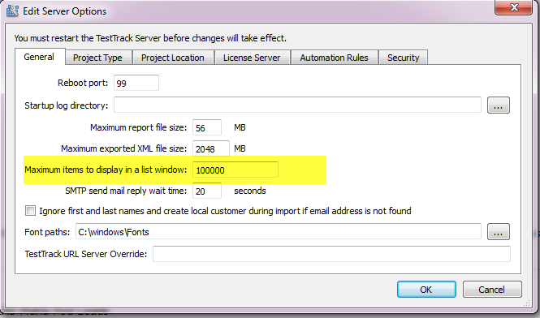

We cap that value at 100k for client side performance. The more items displayed the more memory the client machine requires.

If the value in your Registry Utility is already 100k and you would like to increase it you can do so in the registry by going to: HKEY_LOCAL_MACHINE > SOFTWARE > Wow6432Node > Seapine Software > TestTrack Pro > TestTrack Server and changing the ‘MaxListWindowItems’ value.

cid:image002.png@01D1C09E.5E735EC0

Otherwise you will have to have the list window filtered at all times to not display that message.